**ASSIGNMENT 6**

1. **4-bit Shift Register**

* **Underlying circuit**

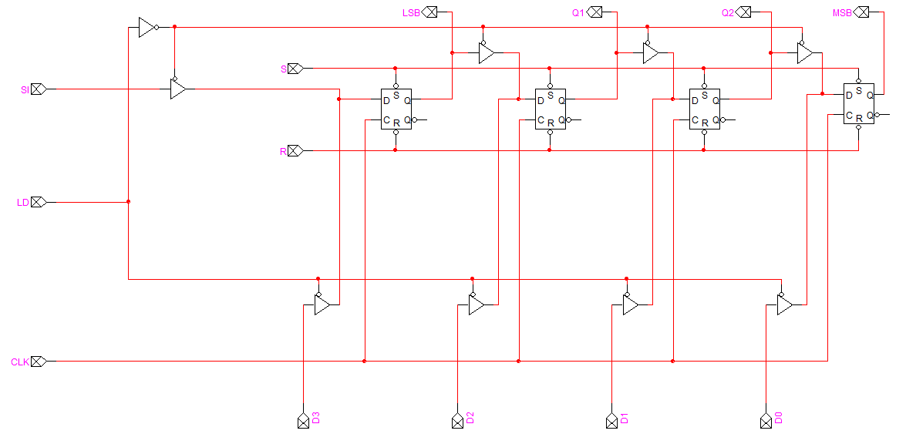

* **The testing circuit of the 4-bit right shift register device**

Load Mode (Storing Input)

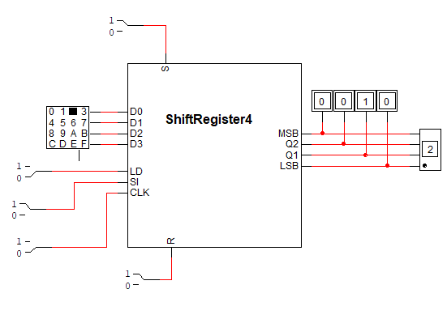

Shift Mode (Shifting Digits one by one)

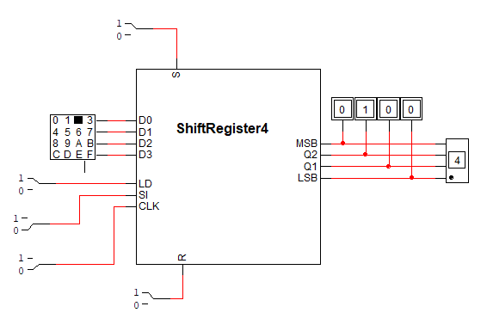

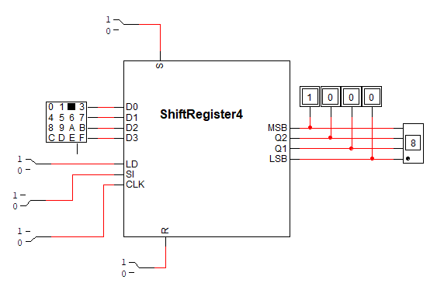



1. **B = 0011**

**A = 0001**

**+ 0100**

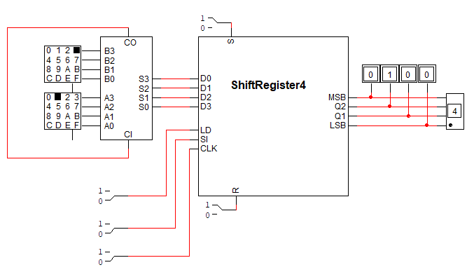

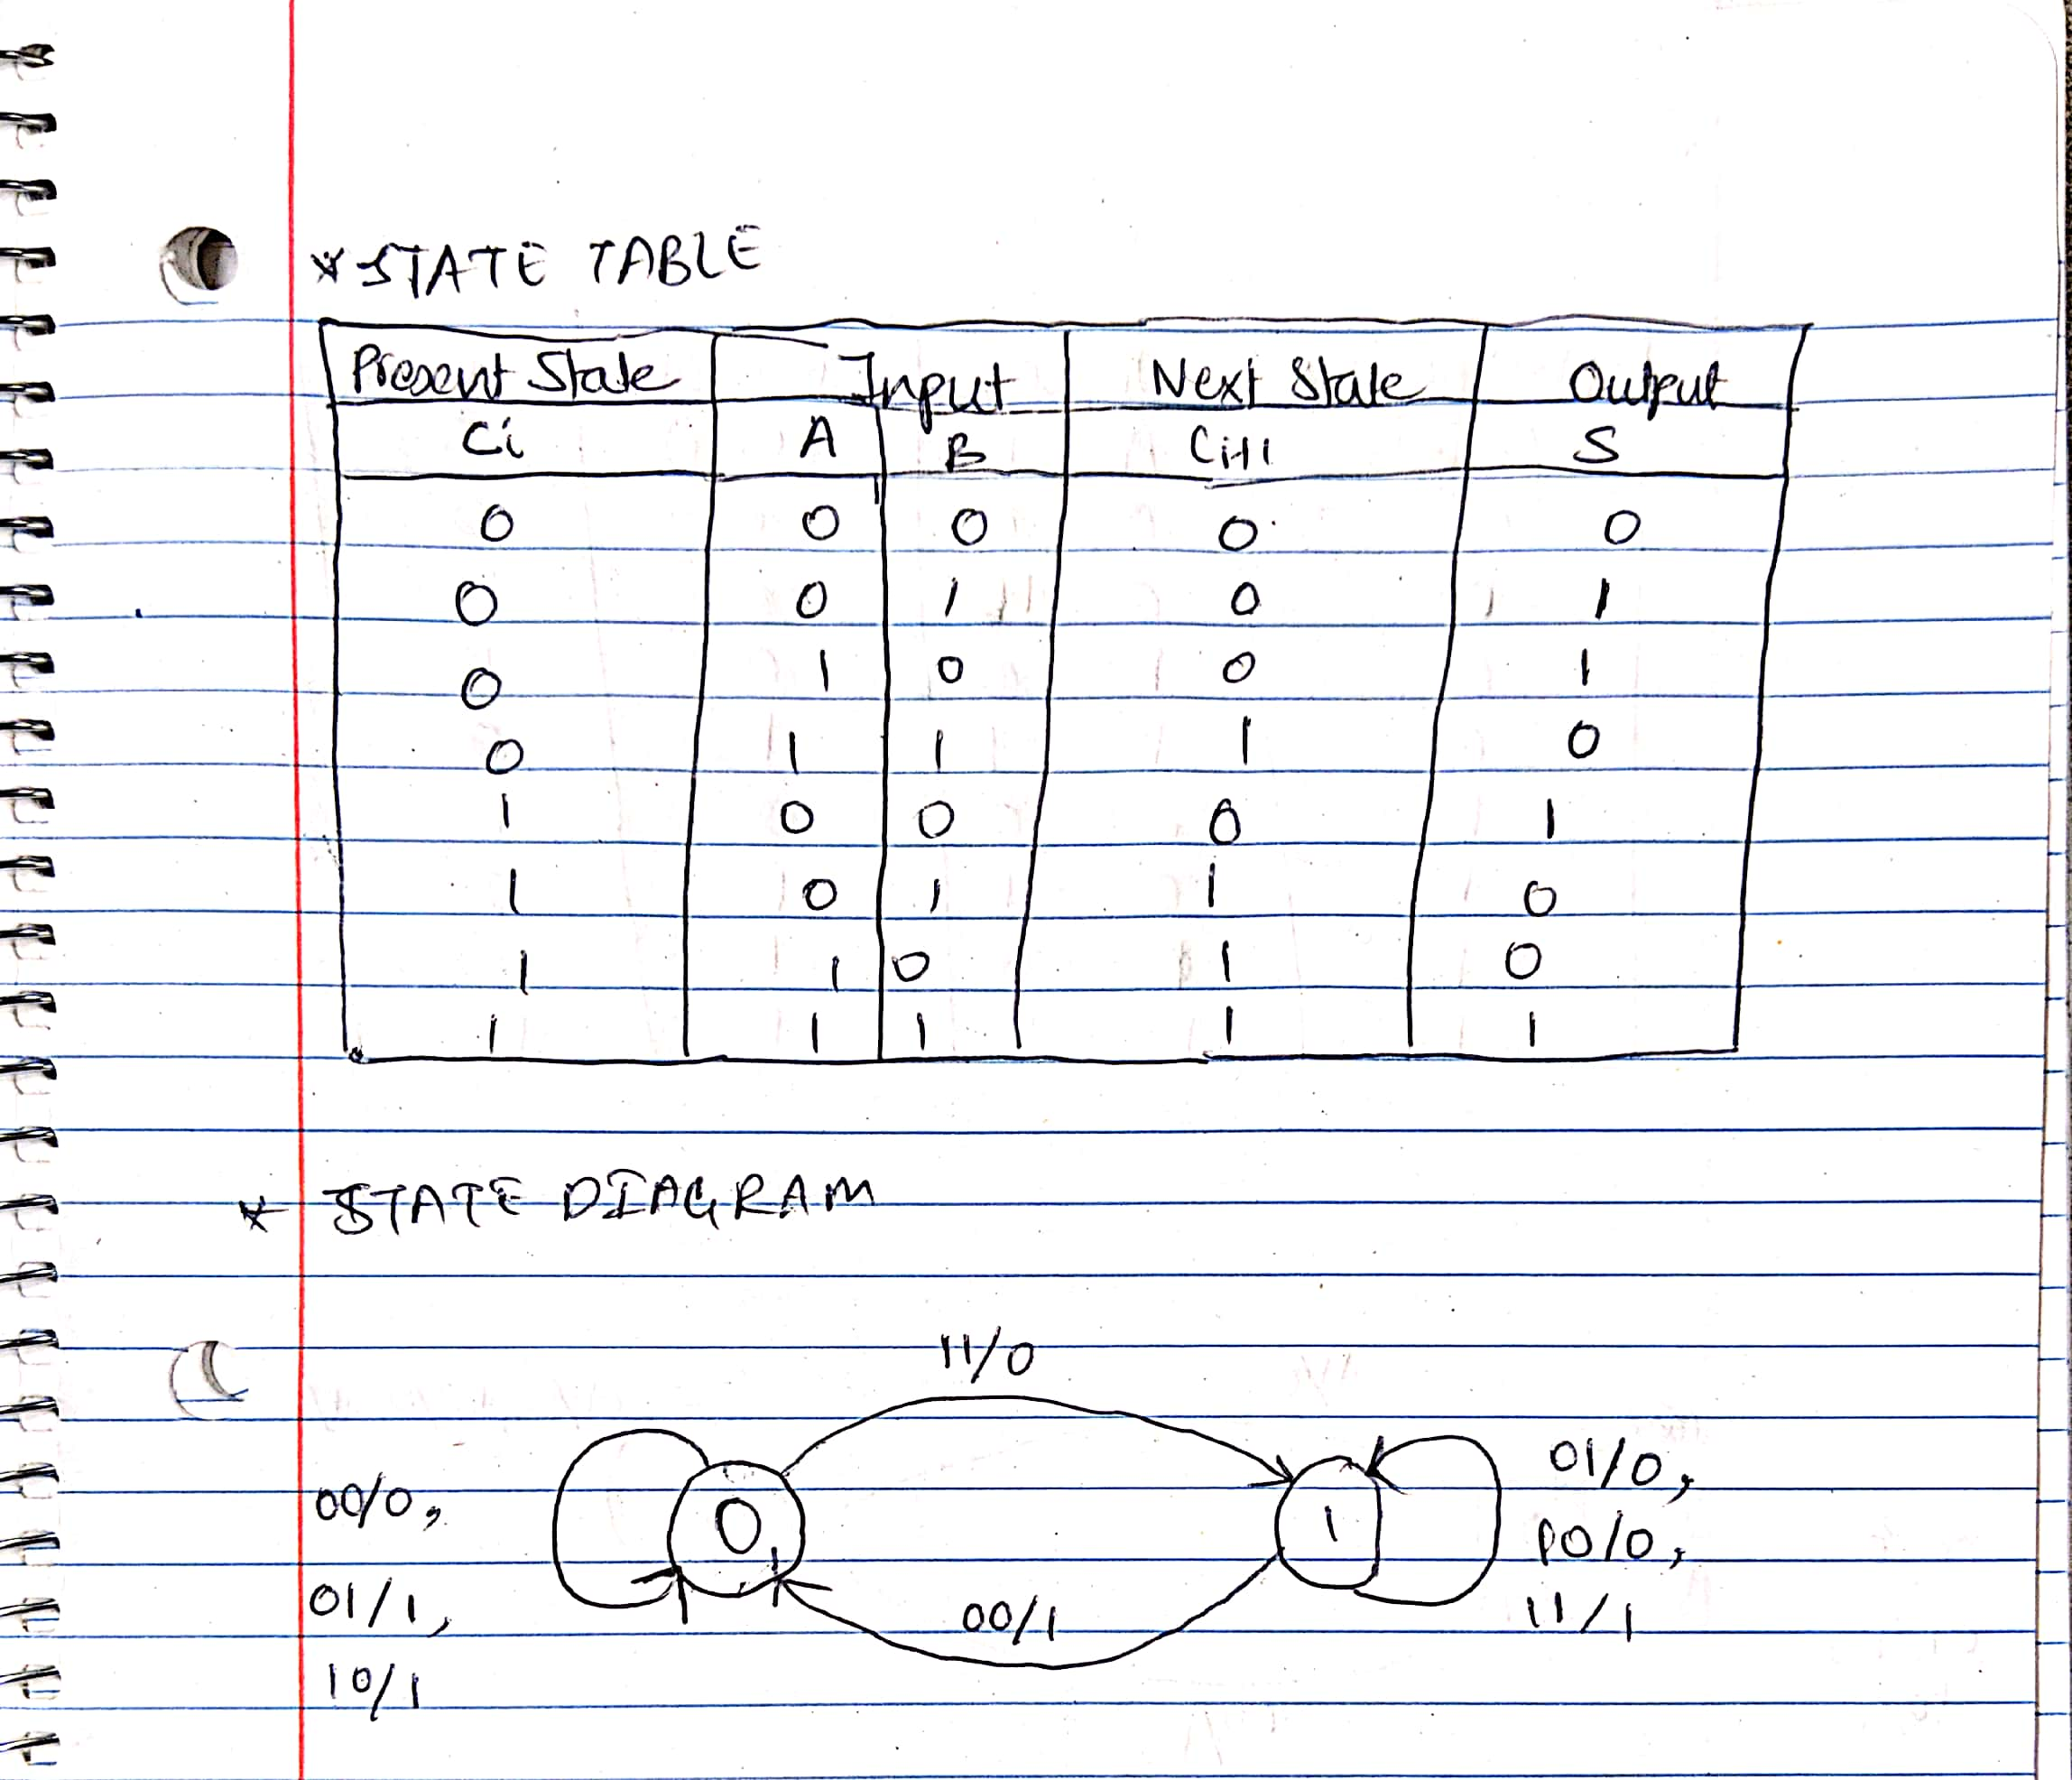

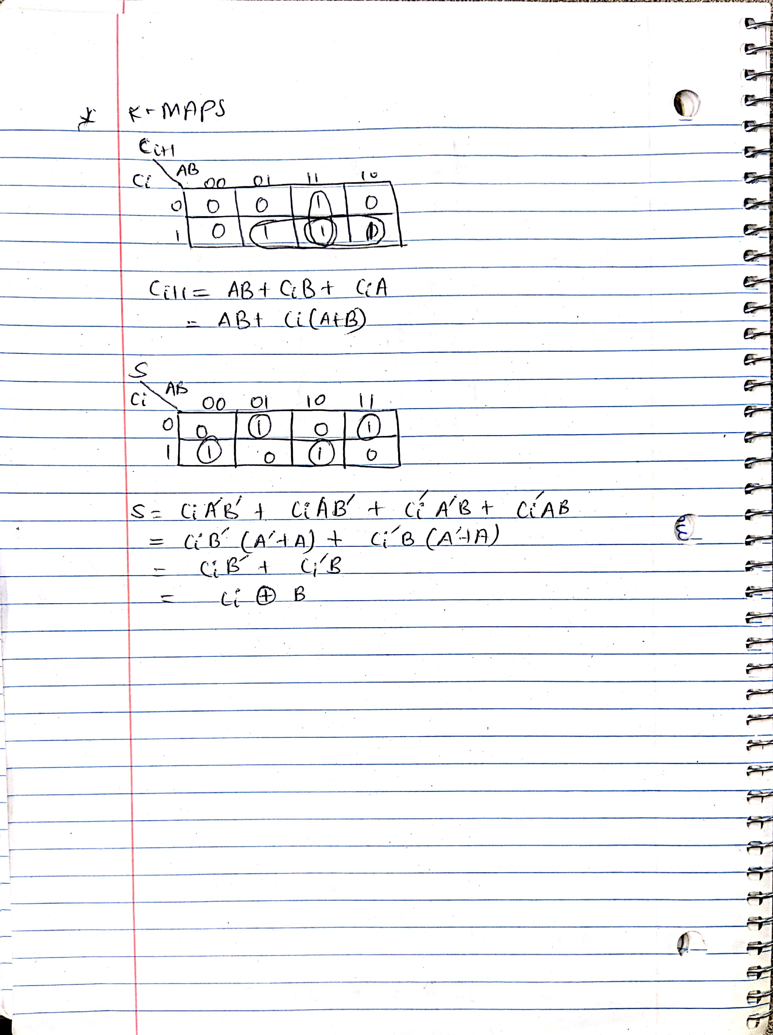

1. **B = 0011**

**A = 0101**

**- = 0010**



